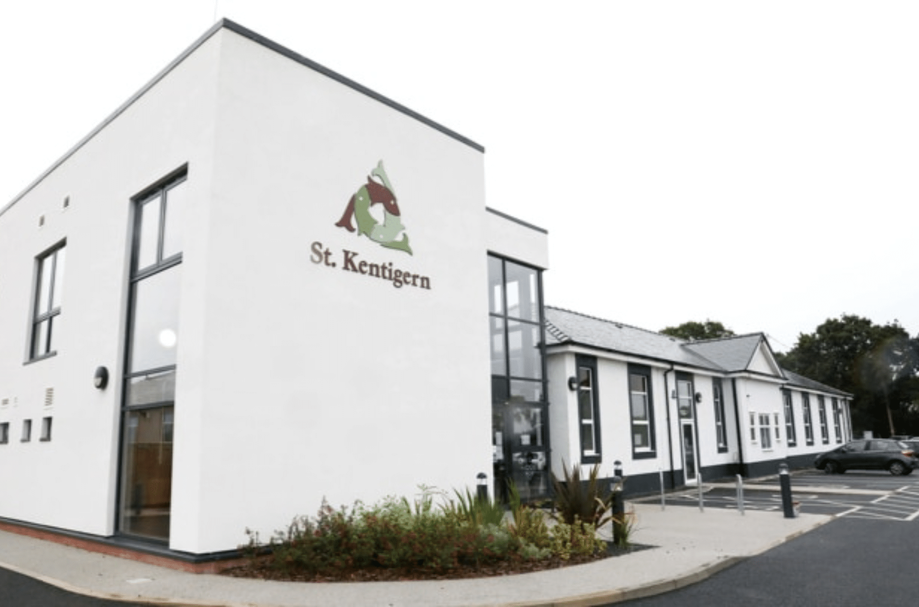



Chief Executive Officer
Recruitment Pack – February 2026

A Message from the Chair of the Board

Dear Candidate,

Thank you for your interest in the role of Chief Executive Officer at St Kentigern Hospice.

Our hospice plays a vital role in providing compassionate, high quality end of life care to patients and families across North Wales. We are a well performing organisation as evidenced in our most recent HIW Report, however the sector as a whole is facing unprecedented financial challenge. We need an exceptional Chief Executive Officer to lead the hospice through a period of transformation to achieve long-term sustainability. This role requires a rare combination of strategic clarity, financial rigour and human leadership- someone who can lead transformation without losing sight of what matters most. You can find out more about how St Kentigern Hospice supports our patients and their families via our website https://stkentigernhospice.org.uk/ where you can read our strategy for 2023-2028, our latest Health Inspectorate Wales report and our Annual Reports.

As CEO, you will be accountable to the Board of Trustees for the overall performance, sustainability, and regulatory compliance of the hospice. You will ensure that the corporate strategy and financial plan are tightly aligned to delivery, performance management, and regulatory expectations and that opportunities for efficiencies are optimised. You will work within the frameworks of the Charity Commission, Welsh Government, NHS Wales, and Healthcare Inspectorate Wales (HIW), ensuring the hospice consistently delivers safe, effective, and compassionate care while maintaining public trust and confidence.

We are looking for a resilient, compassionate and values-driven leader with:
- Senior leadership experience
- A proven track record of strong financial management, or organisational transformation
- Strong commercial and business acumen, alongside a deep appreciation of charitable purpose and public benefit
- Experience of working with boards and within robust governance and regulatory frameworks
- The ability to align strategy to delivery through disciplined performance management
- Confidence working with healthcare regulators and partners, including inspection and assurance processes
- Outstanding leadership, communication, and stakeholder engagement skills
- Experience within hospice care, healthcare, or the third sector is desirable, as is knowledge of the Welsh health and social care system.

This is your chance to make a lasting difference, to safeguard vital services for communities across North Wales and to lead an organisation with compassion, integrity, and purpose. You will inherit committed staff, volunteers, and trustees, and the opportunity to shape a sustainable future for hospice care in the regi

If this sounds like the next step for you, we would be delighted to hear from you. For further information and an informal discussion please contact our retiring CEO Jane McGrath.
E mail j.mcgrath@stkentigernhospice.org.uk

Steve Thomas
Chair of the Board of Trustees
St Kentigern Hospice

About St Kentigern Hospice

Our hospice opened in 1995 and celebrated its 30th Anniversary in 2025. Our hospice is based in St Asaph, North Wales, and serves the needs of the local populations living in Denbighshire, East Conwy and West Flintshire, which together have a catchment population of around 220,000.

We employ around 90 staff who work together to provide a wide range of services including inpatient care to support patients who require symptom management, rehabilitation, respite and end of life care. We care for people during the advanced stages of all life-limiting conditions, including cancer, heart failure, respiratory, renal and neurological diseases.

Our outpatient services continue to develop and includes our Wellbeing Hwb which provides a range of support, therapy and activities for patients, their carers and families. We offer complimentary therapy as well as music and art therapy. We are the only hospice in Wales to have an Admiral Nurse who provides support for families and people living with advanced dementia.

We are supported by over 300 volunteers who provide a vital resource across all functions of our organisation. From working on the wards, providing an essential meet and greet service to volunteering in our shops and the many fundraising activities that all contribute to our vital income generation work.

Our Mission, Philosophy and Values

Our Mission
We are an independent charity that aims to improve the quality of life for adults in Denbighshire, Conwy and Flintshire with a life-limiting illness.

Philosophy of Care
Our care is centred on the patient, we respect individuality and each person’s dignity and right to privacy. We care for the whole person, their physical, emotional, spiritual, social needs and goals. The care includes support for their families and carers through an individual’s illness and into bereavement.

Our Values
Our values are our guiding principles and inform everything we do in how we care for our patients, their families and carers; how we behave with each other as members of staff and volunteers, and in how we plan, develop and fund our services.

In living our values, as an organisation we:

- Put patients, their families and carers at the heart of all we do
- Focus on each individual person’s needs, beliefs and lived experience and what matters to them
- Are open and honest in our communications
- Act with integrity at all times
- Ensure confidentiality in all that we do ensure our services are accessible and inclusive
- Focus on delivering high quality care
- Ensure we are accountable for all that we do
- Are committed to continuously improving our services
- Exercise probity and value for money in how we spend our fundsOur Strategy 2023 - 2028

Our strategy is centred around six core objectives:

Objective One: Develop our hospice model of care
Objective two: Be an employer of choice and first choice for volunteering (Our people)
Objective Three: Ensure financial stability and sustainability (Our income)
Objective Four: Be a learning and teaching organisation, including participating in research
Objective Five: Work in partnership and collaborate with statutory and non-statutory bodies, including third sector.
Objective Six: Raise awareness of our hospice and the provision of palliative and end of life care.

Organisational Chart
Chair & Board of Trustees

Chief Executive Officer

Head of Income Generation, Marketing & Communications
Matron
Operations Manager
Finance Manager

Corporate Governance Chart
BOARD

Sets hospice strategic direction, agrees hospice annual budget and monitors the performance of the CEO, management team and Committees to ensure delivery of the hospice strategy and the safe and effective running of all aspects of service delivery

QUALITY AND SAFETY COMMITTEE

Reviews and oversees all matters relating to the quality and safety of patient care and the delivery of clinical services
GENERAL PURPOSES COMMITTEE

Reviews and oversees all matters relating to the delivery of non-clinical services and organisation wide matters, such as Health and Safety, Information Governance and Human Resources
AUDIT AND GOVERNANCE COMMITTEE

Reviews the overall governance of the hospice, reviews internal controls, risk management systems and external audit.
FINANCE COMMITTEE

Reviews and oversees hospice financial performance and all matters relating to hospice finances

Job Description
Chief Executive Officer (CEO) St Kentigern Hospice
Salary: Circa £75,000 per annum
Location: North Wales
Accountable to: The Board of Trustees
Purpose of the Role
As the principal ambassador for the Hospice the Chief Executive Officer will provide decisive, values-driven leadership to transform and ensure sustainably of the hospice at a time of significant financial challenge. As such a core function of the role is to lead and personally champion income generation. The organisation requires strong financial, commercial, and strategic leadership to ensure financial resilience, strengthen governance and accountability, and enable high-quality hospice care to meet the needs of patients, families, and communities across North Wales. The post holder will ensure that the corporate strategy and financial plan are tightly aligned to delivery, performance management, and regulatory expectations and that opportunities for efficiencies are optimised. The CEO will lead within the frameworks of the Charity Commission, Welsh Government, NHS Wales, and Healthcare Inspectorate Wales (HIW), ensuring the hospice consistently delivers safe, effective, and compassionate care while maintaining public trust and confidence.

Key Responsibilities

Strategic Leadership
- Lead the ongoing development and delivery of a clear, realistic, and financially sustainable corporate strategy aligned to the hospice’s charitable purpose and values.
- Horizon scan to identify emerging trends, risks, policy changes and opportunities that may impact service delivery. Including artificial intelligence (AI) and digital technologies.
- Translate strategic objectives into robust delivery plans with measurable outcomes, milestones, and accountability.
- Ensure organisational priorities reflect the needs of patients, families, staff, volunteers, funders, and commissioners across North Wales.
Financial Leadership & Business Management
- Take overall responsibility for the financial health of the hospice, leading long-term financial sustainability.
- Develop and deliver a credible financial improvement plan, including cost control, income generation, and efficiency improvements.
- Strengthen financial planning, budgeting and forecasting, management.
- Drive optimisation of income streams, including fundraising, retail, grants, partnerships, and statutory funding.
Organisational Transformation
- Lead and manage organisational restructuring to ensure the hospice has the right structures, skills, and capacity to deliver its strategy.
- Ensure roles, responsibilities, and decision-making authorities are clear and effective.
- Manage change sensitively and transparently, maintaining staff and volunteer engagement while delivering necessary improvement.
Governance, Risk & Accountability
- Act as the Registered Responsible Individual under Health Inspectorate Wales regulations.
- Work closely with the Board of Trustees to strengthen governance, assurance, and accountability arrangements.
- Ensure clear reporting frameworks, performance dashboards, and risk management systems are in place and effective.
- Support the Board to fulfil its statutory and strategic responsibilities.
- Ensure compliance with all relevant legal, regulatory, and charity governance requirements including the charity objectives laid out in the Hospice Memorandum and Articles of Association.
- Act as the Senior Information Risk Owner (SIRO)
- Act as the Anti Money Laundering Officer and as such be registered with the Gambling Commission.
- Ensure effective risk management, health and safety and audit systems are in place.
Performance Management & Delivery
- Embed a strong performance management culture across the organisation, with clear objectives, key performance indicators, and regular review.
- Ensure clinical, operational, and corporate performance is monitored, challenged, and improved.
- Hold the senior leadership team to account for delivery against agreed plans and outcomes.
Leadership & Culture
- Provide visible, inclusive, and compassionate leadership that reflects the hospice’s values and mission.
- Maintain a high performing senior leadership team with clear accountability and collective ownership of results.
- Foster a culture of openness, learning, and continuous improvement across staff and volunteers.
External Relations & Partnerships
- Act as the principal ambassador for the hospice, building strong relationships with commissioners, health partners, local authorities, funders, and the wider community.
- Represent the hospice across regional and national networks, particularly within health and social care in Wales.
- Strengthen the hospice’s reputation, influence, and impact across North Wales.
Values & Approach
- Combine financial rigour and strategic discipline with empathy, integrity, and respect for the hospice’s mission, people, and communities, keeping patient care and dignity at the heart of every decision.

Person Specification
Essential

- Strong alignment with hospice values and commitment to inclusion and compassionate high-quality care
- Educated to degree level or equivalent
- Evidence of continuous professional development including a management qualification
- 3 yrs senior leadership experience
- A proven track record of strong financial management, or organisational transformation
- Strong commercial and business acumen, alongside a deep appreciation of charitable purpose and public benefit
- An understanding of the opportunities and risks presented by AI and digital technologies
- Strong understanding of governance, risk management, and accountability frameworks.
- Experience of working with boards and within robust governance and regulatory frameworks
- The ability to align strategy to delivery through disciplined performance management
- In depth knowledge of income generation including fundraising and charity retail, with a proven understanding of how to maximise and diversify revenue streams within a charitable environment
- Confidence working with healthcare regulators and partners, including inspection and assurance processes
- Outstanding leadership, influencing, communication and stakeholder engagement skills
- Ability to travel

Desirable
- Experience within the hospice, healthcare, charity, or public/third sector environment.
- Senior leadership experience within both large and small organisations
- Knowledge of the Welsh Health and Social Care System
- Masters level Degree
- Welsh language skills or a commitment to learning Welsh.

Recruitment Timetable

If you would like to apply, please send the following:

- Your Curriculum Vitae
- And a supporting statement outlining how your knowledge, skills and experience meet the requirements of the role ( max 1,500 words)

Closing Date | 16th March 2026
Informal Meet and Greet | W/B 30th March 2026
Face to face interviews including presentations | W/B 6th April 2026
Anticipated Start Date | TBC

Short listed candidates will be invited to interview; details of a presentation topic will be forwarded. A pre interview focus group will be held for shortlisted candidates, this will include members of staff, trustees, volunteer’s patients and families.
Please let us know of any access or additional requirements you may require.

