

**Information Pack**

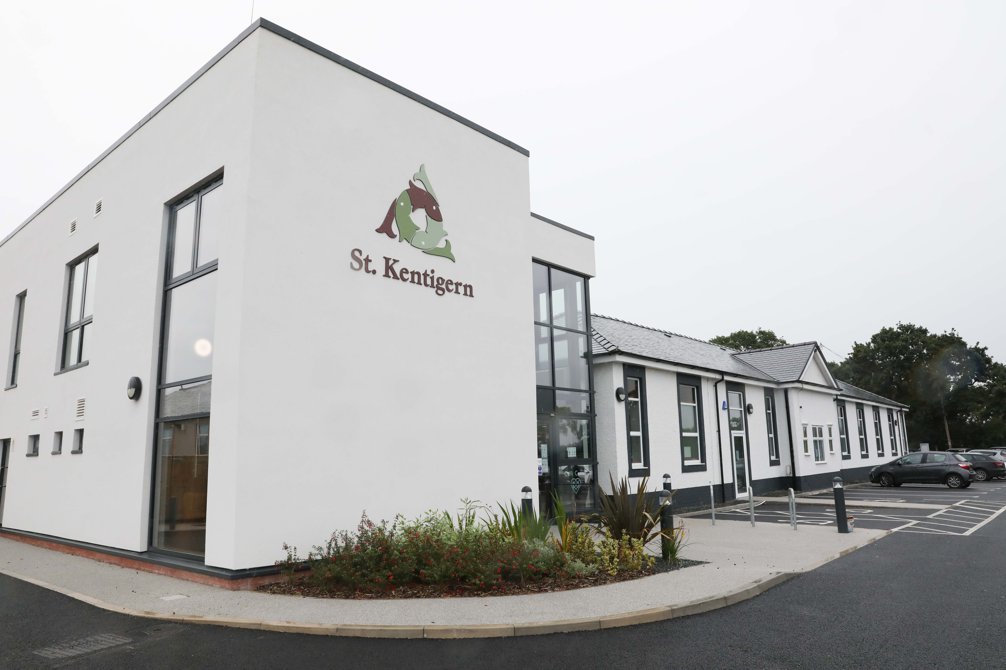

# A message from the Chairman of the Board

**Dear Candidate,**

Thank you for your interest in the role of Chief Executive Officer at St. Kentigern Hospice and Palliative Care Centre.

St Kentigern Hospice is committed to making our specialist care available to as many people as possible within the communities that we serve and we continue to identify and implement innovative ways to increase our reach. We care for patients with a widening breadth of illnesses and at varying times in their diagnosis.

But we know we can do more. We have recently completed a refurbishment and extension to our main building, increasing the number of Inpatient beds we have, as well as redeveloping our Well Being Hwb to better suit the changing palliative needs of our community. Our current Chief Executive, Iain Mitchell MCSP, is retiring as the Hospice celebrates its 27th anniversary.

The Covid-19 pandemic has brought many challenges to everyone, both personally and professionally and as we continue to adapt to the changing world in which we live and work, we are looking for a strong and inspirational leader to navigate us through this rapidly changing environment.

We are seeking someone who will build and maintain excellent working relationships with key stakeholders, the local Health Board and local decision makers, whilst representing and promoting St Kentigern in a professional and positive manner. In addition, of course we need a person who can ensure we raise sufficient funds to help us develop.

I would encourage shortlisted candidates to visit St Kentigern Hospice and meet with Iain and his team. There will also be an opportunity to inspect our refurbished and extended Hospice building.

Changes that are taking place nationally and locally mean we are working even more closely with colleagues in health and social care to ensure that we are in the best position possible to support our patients and their families.

Moving forward will be challenging and exciting and we are looking for a new Chief Executive who can provide strong strategic leadership and inspiration as we tackle these challenges together.

Our new Chief Executive will join a team of compassionate, aspiring and professional people at a very challenging time in our history. Every day is different here, and it is an exciting, supportive and caring place to be.

This candidate pack includes key dates for the interview process.

If you would like to know more, please contact Iain on 01745 585221 or iain.mitchell@stkentigernhospice.org.uk

**Jim O’Toole**

Chairman of the Board of Trustees

St Kentigern Hospice

# About St Kentigern Hospice

**St Kentigern Hospice has been at the heart of the Vale of Clwyd, Denbighshire, East Flintshire and west Conwy community for 27 years and we are here to help people with life-limiting illnesses. Our aim is to try and improve the quality of life for our patients and help them to live life to the full, to the very end. We do this by offering specialist palliative and end of life care, comfort and support, free of charge, to patients and their families. We are an independent charity, based in St Asaph, Denbighshire and rely heavily on funding from our local community and local health board to ensure our care is available for future generations.**

## Our Mission

We are an independent charity that aims to improve the quality of life for adults in Denbighshire, Conwy and Flintshire with a life-limiting illness.

## Philosophy of Care

Our care is centred on the patient, we respect their individuality and their right to dignity and right to privacy. We care for the whole person – their physical, emotional, spiritual, social needs and work with them to achieve their goals. The care includes support for their families and carers throughout an individual’s illness and into bereavement.

We care for people during the advanced stages of all life-limiting conditions, including cancer, heart failure, lung, kidney and neurological diseases.



## Our Values

Values that we live and breathe in our day to day work:

* Community support
* Diversity & Respect
* Innovation & improvement
* Reputation
* Compassion
* Going the extra mile
* Team work
* Every penny counts
* Passion & positivity

## Our Strategy

Our current strategy is being developed and a key function of the role will be the drafting of a new five year strategy for St Kentigern Hospice. It will be supported each year by a more detailed annual plan which will set out what actions we are taking in order to achieve our strategy. We produce an annual report each year to update the community on our progress.

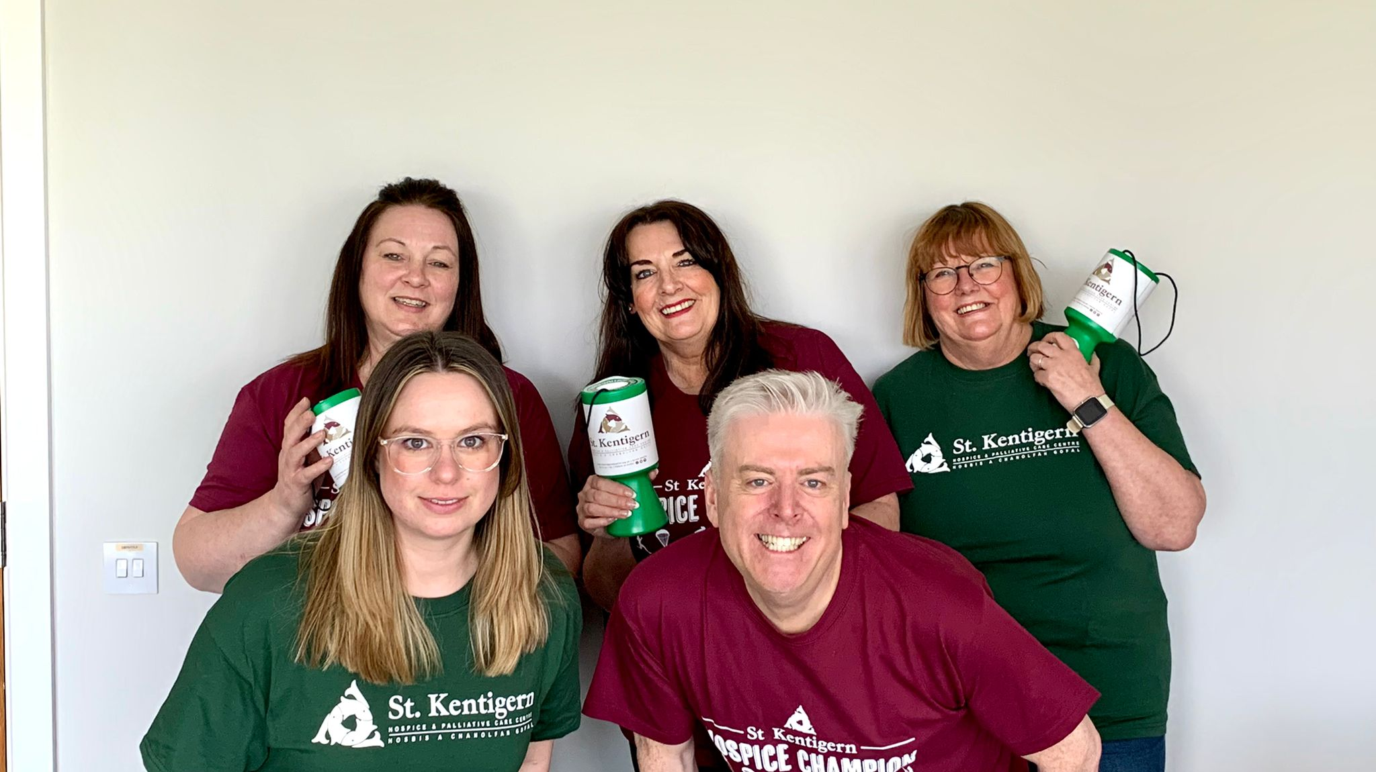

## Our Services

### Inpatient Unit

Our Inpatient Unit aims to manage the physical and emotional effects of a wide range of life-limiting illnesses alleviating pain and easing any distressing symptoms, ensuring we help our patients maintain their dignity and independence.

We offer a homely and welcoming environment, offering a safe place in which patients can be themselves. We are patient-focussed and appreciate that the little things matter, aiming to create an atmosphere of mutual respect, gentle good humour and warmth. We strive to accommodate the needs of patients and their families by being as flexible as possible regarding visiting times and pet visits. We offer home-cooked food and appreciate that a little bit of what you fancy does you good.

Our Inpatient Unit consists of:

* 12 single en-suite rooms, one of which is a bookable respite room
* All have access to the gardens
* A relatives’ room (as Required)

A significant number of patients are able to be discharged home from the Inpatient Unit

The Clinical team comprises of :

* A matron
* Senior sister
* Deputy Ward Sister
* Advanced Nurse Practitioners
* Staff nurses
* Health Care Support Workers
* Specialist Doctor (Sessional Basis from Health Board)
* Palliative Care Consultant (Sessional Basis from Health Board)
* Bereavement Counsellor (Family Support Team Lead)
* Social Worker( Family Support Team)
* Physiotherapist
* Occupational Therapist
* Admiral Nurse (Dementia Care Specialist)
* Ward Clerk
* Complementary Therapists
* Music Therapist
* Chaplain (vacant post)
* Art Therapist (vacant post )

We embrace all of our community and we respect the individual beliefs of all of our patients and accommodate their needs as best we can.

Referrals to our Inpatient Unit can be made by a GP, District Nurse, Hospital Team or Specialist Palliative Care Team. Each referral is assessed on an individual basis by our Clinical Team against our referral / admission criteria.

### Well Being Hwb (Day Therapy)

Day Therapy and the Wellbeing Hwb are an integral part of the care we offer at St Kentigern. It enhances quality of life for patients by helping maximise independence through engaging in activities and therapies and provides personalised care in a relaxed environment. It also offers the opportunity for patients to meet other people who are going through a similar experience enabling them to share concerns in a supportive environment. The team offer a wide range of medical and nursing care alongside therapies and support from our Patient and Family Support team.

### Patient and Family Support

It’s not just our patients who need our care and support – we also help those who are important to them.

The Patient and Family Support team are part of the multi-disciplinary team within the Hospice working within the Inpatient Unit, Day Therapy and Wellbeing Hwb. The team strive to meet everyone’s physical, social, emotional and spiritual needs and are supported by a small number of trained and experienced volunteers.

Each of our services offers a range of support including pre and post bereavement support, emotional support, future care planning, personal/family concerns as well as practical problems and signposting to appropriate external agencies.

They work closely with other Hospice teams and with outside agencies such as social services, local health care professionals, schools and advisory services.

# Income Generation

We have an active fundraising programme to generate the funds needed each day to meet our costs. Fundraising is a vital part of hospice life, as is the friendship and support of the community we serve. St Kentigern Hospice stands as a tribute to the commitment and generosity of the many people of our catchment area who provide continual and enthusiastic support to help us carry on caring

As a charity we are dependent on donations, legacies and fundraising to pay for the care we provide. St Kentigern Hospice costs over £2 million to run each year. Although Betsi Cadwaladr University Health Board contributes towards this, the rest is raised by the generous support of our community.

## Retail

The Hospice runs 10 shops and a new Distribution Shop and Centre across Denbighshire, Conwy and Flintshire, selling furniture, clothes, vintage items, bric a brac, and electrical items etc. All donations are very welcome. Recycling is also important to the Hospice; used stamps, foreign coins, books and even rags can be sold to raise funds. We have an active online sales site which is based at our recently opened Distribution Centre in Rhyl.

## Lottery

Members of the lottery have the opportunity to support the Hospice whilst also being part of a weekly prize draw with a main prize of £1000. By taking part in our lottery our supporters help to raise an average of £180,000 each year.

## Volunteers

The value placed upon our volunteers is immeasurable. We have recently recruited a Volunteer Coordinator to further recruit more volunteers. Some volunteers have a regular commitment and others help on an occasional basis.

We have over 150 volunteers who work alongside paid staff in the Hospice, our shops and at events. In addition, we have local support groups who each have a team of willing volunteers helping at the events they organise.

Due to Covid-19 many of our volunteers have been unable to return to their usual volunteering role but we hope that they will be back supporting the Hospice soon.

## Role of The Board of Trustees

The Board of Trustees is primarily concerned with direction, policy and strategy. The management of the Hospice is delegated to paid professional staff who report back to the Board.

Every Independent Hospice is a charity controlled by a Board of Trustees who are responsible for the overseeing and administration of the charity. They are accountable for the governance of the charity, making decisions and working together through meetings of the Board of Trustees. The Board is legally accountable for the activities of the hospice. It is responsible for establishing its mission, vision and values and has a framework of policies and standards. The Chief Executive and senior management team, have delegated responsibility for implementing the Boards strategy and to monitor the performance of the hospice. A key responsibility of the Board is to ensure that the Hospice provides the highest quality of care, balanced with the effective, efficient and economic use of hospice resources and assets. The Board ensures compliance with all legal and statutory duties and meeting St Kentigern’s Memorandum and Articles of Association

# Working at St Kentigern

St Kentigern employs dedicated people who want to make a contribution to individuals and their families in need of Hospice care. All roles are valued and we work very much as a team. We have identified several behaviours (listed below) which we believe are essential to being a member of the St Kentigern organisation.

**empathetic motivated pro-active dedicated Accountable innovative Respectful**

## Senior Management Team (SMT) Members

* Chief Executive Iain Mitchell MCSP
* Medical Advisor Dr Andrew Schuler
* Matron Jane McGrath
* Finance Manager Nichola McGowan
* Operational Manager Joyce Bellingham
* Retail Manager Val Corner
* Fundraising Manager Michaella Brannan
* Hospitality Manager Delyth Edwards-Roberts



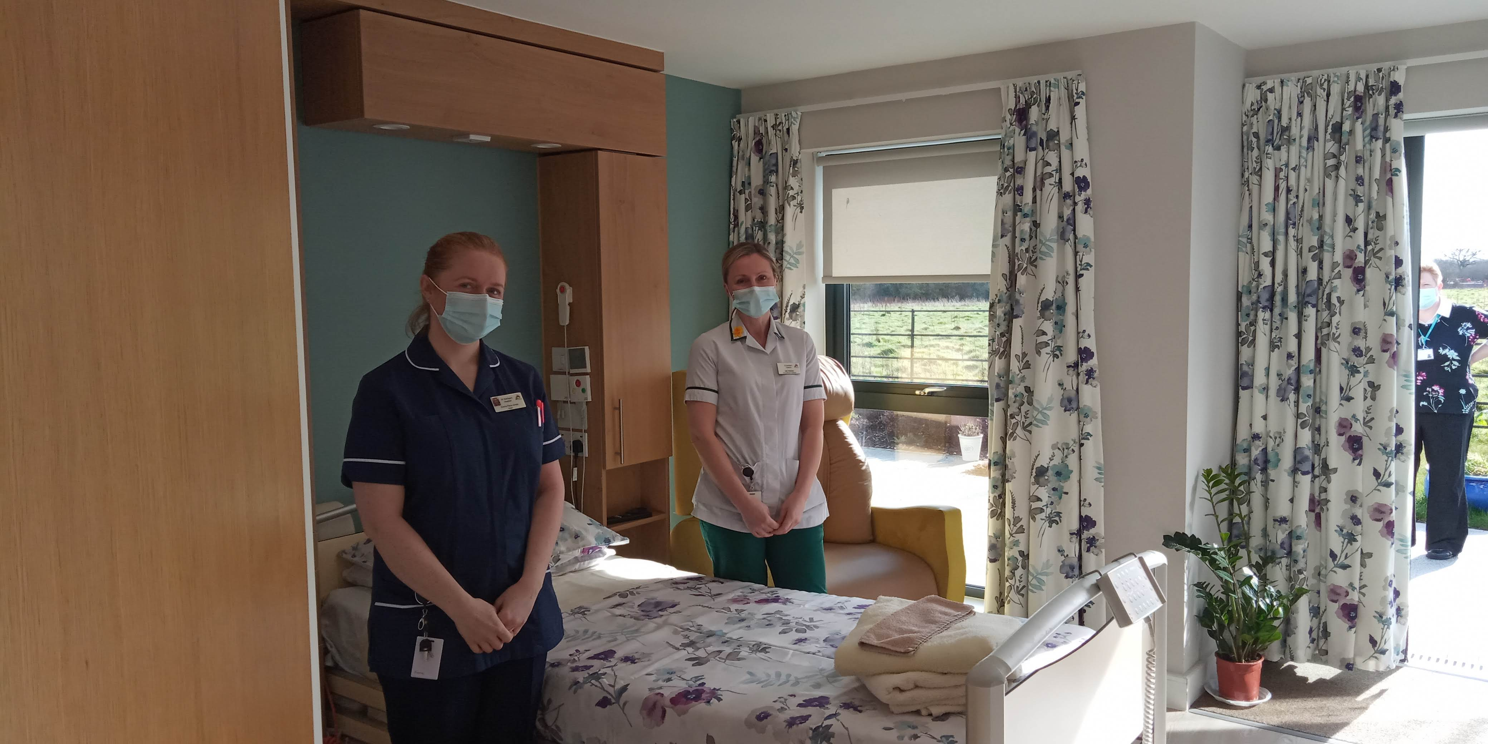

# Working at St Kentigern

## Recruitment Timetable

**26.08.22**

Closing Date

**05.09.22**

Informal ‘Meet and Greet’

**12.09.22**

(

)

Face to face interviews including presentation

**w/c 03.01.23**

Anticipated start date or earlier by mutual agreement

**End of January 2023**

Current Chief Executive leaves or earlier by mutual agreement

**Notes**

The interview panel will comprise of members of the Board of Trustees.

Details of the presentation will be sent to shortlisted applicants with the invitation to interview.

Meet and greet will comprise of members of Hospice staff and trustees; further details will be given to successful applicants.

# Job Details, Benefits & Information

|  |  |
| --- | --- |
| **Employment** | The Employer is St Kentigern Hospice    The first 6 months of employment are on a probationary basis. |
| **Terms & Conditions** | The Hospice operates its own terms and conditions of employment which are not linked to any national or local agreements. |
| **Annual Leave** | 25 days plus 8 days bank holiday pro rata.  The leave year runs from 1st April to 31st March each year. |
| **Pay Review** | Your salary will be reviewed for the purposes of any pay increase on an annual basis. There is no entitlement to an increase in salary as a result of an annual pay review and a pay increase awarded as a result of such review in any one year shall not oblige the Hospice to make a pay increase in subsequent years. Any increases to your pay are purely discretionary. |

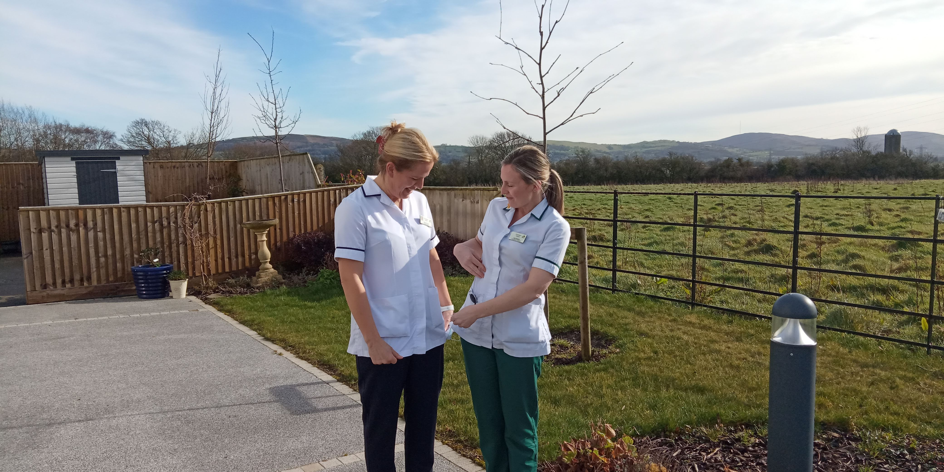

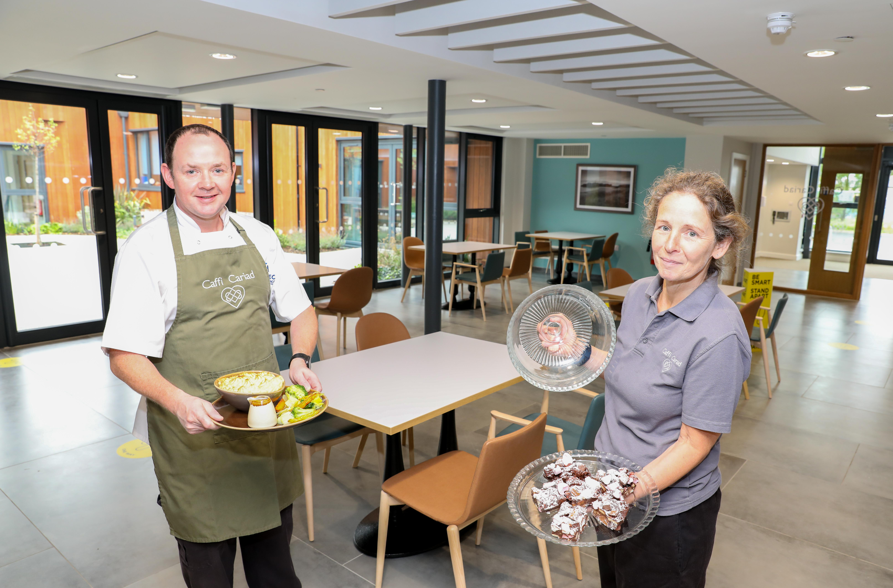

|  |  |  |
| --- | --- | --- |
| **Sick Pay** | The entitlement to St Kentigern sick pay entitlement depends on the length of continuous service and is calculated within a rolling 24 month period. During the probationary period, Statutory Sick pay only applies.  Entitlements to OHSP depend upon completed years’ service:  **Lengths of Service Full Pay Half Pay**  During Probation Statutory Sick Pay only  6 to 12 months 1 week full pay  Over 1 & under 2 years 2 weeks full pay  Over 2 8 weeks 8 weeks | |
| **Smoking Policy** | A no smoking policy operates on all Hospice premises and in Hospice vehicles. There is a designated smoking area within the Hospice grounds for patients and visitors. | |
| **Pension** | The Hospice operates a group personal pension scheme and in compliance with the employer pension duties under the Pensions Act 2008, you will be enrolled as an active member of this scheme (or such other registered pension scheme as may be established by the Hospice to replace the scheme) from the start of your employment provided you meet the conditions for eligibility as notified to you and subject to HM Revenue & Customs requirements.  if the person came from NHS, then we would honour the NHS pension contributions. If they came from elsewhere, they would be auto enrolled into our workplace pension. They could then choose to opt out if they wished. | |
| **Location** | St Kentigern Hospice is located in a residential area in St Asaph, North Wales with easy access to the A55 |
| **Staff Benefits** | Free car parking on the main site in St Asaph  Company Pension Scheme  High quality meals/snacks available to purchase  Café  Mentor, coaching and a wide range of other support  Clear Policies and Procedures  Training and development opportunities  Opportunities to help with fundraising events  Access to occupational health services |
| **Retirement Age** | The Hospice does not have a standard retirement age. |
| **Offer of Employment** | Any offer of employment following interview is made subject to:   * Receipt of two references to a standard deemed acceptable to the   Hospice   * Completion of all required documentation * Evidence of qualifications * Disclosure & Barring Service Check at the agreed level for certain   roles   * Evidence of the right to work and reside in the UK * Medical clearance from Occupational Health Service * Satisfactory bank details to enable a bank transfer for salary purposes |

Any of the above details or conditions may change without notice. Please check any specific details with our current Chief Executive, Iain Mitchell MCSP if you are appointed to the post.



Registered Charity Number 519931