JOB DESCRIPTION
Chief Executive Officer St Kentigern Hospice & Palliative Care Centre

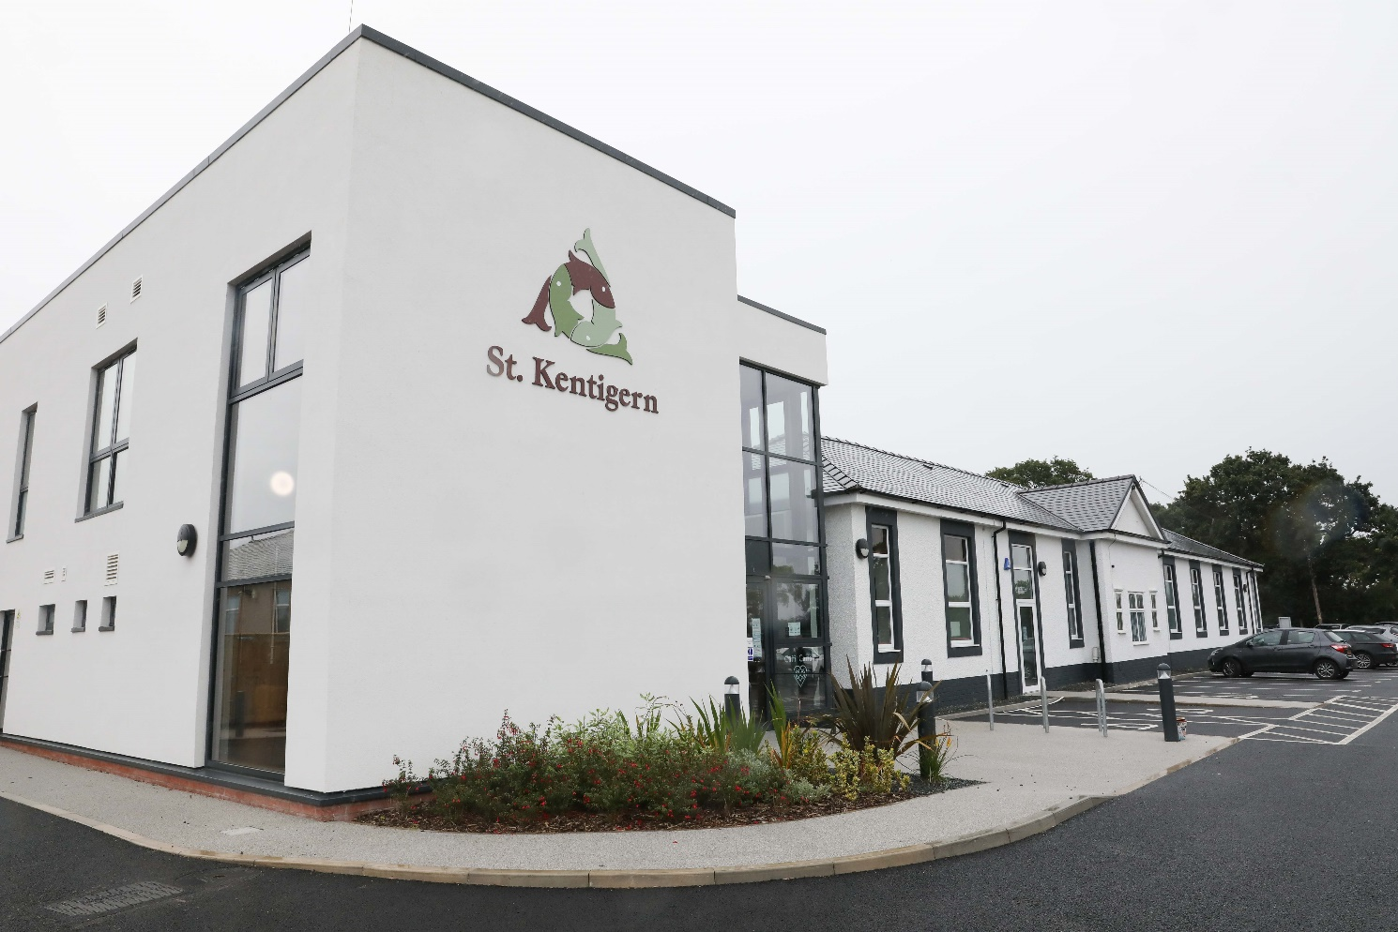

Chief Executive Officer – St Kentigern Hospice & Palliative Care Centre

Hours: The post is offered on a full time or part time basis, based on the needs of the service and in agreement with the post holder.

Salary: £60,000 - £70,000 (pro rata)

Accountable to: Board of Trustees

Job Summary

As Chief Executive you will provide strong and inspirational leadership to develop and deliver our strategic vision and navigate us through a rapidly changing environment

The post holder, working with the Board of Trustees, will lead the Hospice whilst building and maintaining excellent working relationships with key stakeholders and local decision makers, and also representing and promoting St Kentigern in a professional and positive manner.

The post holder will:

- Be an inspirational leader, creating an environment and culture where best practice, governance, relationships and professional development of staff and volunteers flourish

- Be accountable to the Board of Trustees for the overall leadership, management, performance, governance and development of St Kentigern Hospice and review the current management arrangements to ensure they are fit for purpose.

- Build alliances and partnerships with other organisations and act as an ambassador for the Hospice

- Work with the Board to develop and implement the strategic plan, ensuring alignment with the Hospice’s short-term and long-term objectives

- Lead all operational and business activities to ensure effective, efficient and safe running of the Hospice, meeting all clinical, statutory, financial, regulatory and legal requirements

- Work collaboratively with the Board of Trustees and Senior Management Team to continuously improve palliative care services for patients and their families, responding to changing community needs and patient requirements

- Develop and sustain income streams and financial controls which provide ongoing financial security of the Hospice

2

Duties and Responsibilities of the Post:

Strategic

- Provide visionary leadership of the hospice and all its component parts and ensure St Kentigern achieves its mission, values and charitable objectives

- Develop the strategic direction of the hospice, in collaboration with the Board of Trustees and Senior Management Team

- Build effective strategic partnerships and relationships with key stakeholders locally to improve end of life care both regionally and nationally.

- Keep abreast of best practice in the hospice movement, advising the Board of Trustees of risks and opportunities to respond to national and local policy documents and developments that impact on the Hospice and patients with life limiting conditions

- Lead the delivery of short-term and long-term plans within agreed budgets

- Oversee the development and delivery of strategic plans to achieve targets for raising funds to meet running costs, support service development and achieve the capital appeal targets

- Seek external funding opportunities within the public, private and charitable sectors

- Maintain a strong governance framework for the Hospice to meet external legal, regulatory and clinical requirements of statutory bodies including Charity Commission Guidance, the Charity Governance Code and the Healthcare Inspectorate Wales Standards

- Develop a culture and create an environment where people feel motivated and which promotes learning and development of staff and volunteers

- Lead and manage change effectively as required to enhance specialist services and increase patient access within available resource

- Represent the hospice effectively, building trust with key stakeholders and liaising with the media, corporate and individual supporters

Technical

- To be registered with the Gambling Commission to monitor the Lottery

- Will act as the Anti Money Laundering Officer

- Will fulfil the role as the Senior Investigating Reporting Officer (SIRO) for the organisation.

Operational

- Lead and motivate the workforce to develop a high performing Senior Management Team and advance employee engagement

- Support the Registered Manager of the Hospice in meeting the requirements of the role, including meeting Healthcare Inspectorate Wales and other clinical and legal requirements.

- Oversee the fiscal management of the Hospice, including budgeting, reporting and auditing and agree monitoring arrangements with the Board of Trustees

- Ensure that St Kentigern raise the funds needed to maintain the viability of the hospice and meet capital appeal targets.

3

- Ensure that the Hospice has effective risk management, Health and Safety and audit systems in place

- Ensure the hospice provides high quality, effective and efficient services, meeting the standards required of regulatory bodies

- Maintain, develop and implement clinical and non-clinical policies and procedures to deliver safe, high quality services

- Seek ongoing improvements in services to meet the changing needs of our local community regularly reviewing staffing structures to ensure they support service development

- Create a culture that supports the retention and recruitment of high caliber, motivated staff and volunteers

- Ensure effective performance review and appraisal systems are in place and oversee the organisational development plan, providing staff with ongoing learning and development enabling them to deliver their contributions to Hospice’s objectives

- Ensure that incidents and complaints are fully investigated and that learning from them is implemented effectively

Key Working Relationships

Chair and Trustees
Senior Management Team
All other staff and their representative organisations including trade unions
Volunteers
Key Local Partners

Peers at regional, national Hospices and other charities
Peers in the Local Health Board for North Wales and other clinical commissioning groups
Professional and clinical networks which includes Hospice UK, Hospice Cymru and the End of Life Board
Supporters and local businesses
Health Inspectorate Wales

Other Responsibilities

Maintain strict confidentiality in all matters relating to the Hospice, its business, patients, staff and others

Any other activity as reasonably requested by the Board of Trustees.

This job description is an outline of responsibilities and will be subject to review with the post holder in light of the changing needs of the post and Hospice

Safeguarding Children and Adults at Risk

All Hospice staff are required to act in a way that at all times safeguards the health and well-being of children and adults at risk. Familiarisation with, and adherence to, the Hospice safeguarding policies is an essential requirement, as is participation in related mandatory/statutory training.

Valuing Diversity and Equality

All staff should carry out their duties in accordance with the principles of valuing diversity and equity of provision. It is the responsibility of all staff to support the Hospice vision by promoting a positive attitude to diversity and equality of opportunity, to eliminate discrimination and disadvantage in

4

service delivery and employment and to manage, support or comply through the implementation of the Hospice’s Equal Opportunities Policy.

Attributes |  | Essential | Desirable
Qualifications/Training
Educated to degree standard or equivalent |  | X
Masters level/Post graduate management qualification |  |  |  | X
Evidence of continuing professional development |  | X
Knowledge & Experience
Successful track record of leadership at a senior level in a complex |  | X
and diverse environment
Strong strategist, able to identify development and business |  | X
opportunities
Knowledge and experience of risk management |  | X
Ability to understand new issues quickly and make wise decisions in |  | X
light of available evidence and conflicting opinions
Experience of effectively managing resources across an organisation,
including knowledge of balance sheet and cash flow management and |  | X
general budgeting
Knowledge of corporate governance and leadership practices |  | X
Familiarity with various business functions, including fundraising, |  |  |  | X
finance, marketing and PR
Good understanding of current issues in health and social care |  | X
Demonstrable experience of strategic leadership of people, including |  | X
managing change (including culture change ) effectively
Experience of establishing effective working relationships and |  | X
influencing and negotiating with key partners and stakeholders
Knowledge of the hospice movement and charity sector |  | X
Skills/Abilities
Ability to provide strong inspirational leadership and to develop the |  | X
Senior Team
Excellent interpersonal, communication and facilitation skills |  | X
Ability to both listen to and influence people from a wide range of
backgrounds, including volunteers; trustees; external partners; |  | X
patients and families and colleagues
Ability to deal with a wide range of data and information and make |  | X
appropriate decisions from it
Ability to work under the pressure of multiple priorities and to delegate effectively |  | X
Personal Attributes
A natural leader who is visible, has vision and enables others |  | X
Team player who earns the trust and respect of colleagues |  | X

Attributes | Essential | Desirable
Excellent communication and public speaking skills | X
Positive professional approach and image | X
Commitment to the culture, purpose and values of St Kentigern Hospice | X
Commitment to diversity and inclusion | X
Emotionally Resilient, with drive, energy and enthusiasm | X
Welsh Language |  | X

You must be able to demonstrate how you meet the essential or desirable requirements in your application form, CV, supporting statement, documentation or evidence, interview presentation or during interview

Terms of Appointment:

The post is offered on a full time or part time basis based on the needs of the service and in agreement with the post holder

The remuneration for this role will be in the range of £60,000 - £70,000.(pro-rata)

Sélection Process:

Closing Date 26.08.22

Informal meet and greet 05.09.22

Panel Interviews 12.09.22

Appointment made w/e 16.09.22

Successful applicant starting date w/c 03.01.23 or sooner by mutual agreement

How to apply

ow to ApplyHOW
HOW
For further information or to submit application pack please contact our current Chief Executive Iain Mitchell iain.mitchell@stkentigernhospice.org.uk Tel.01745 585221

